

**STUDENT DRESS CODE POLICY**

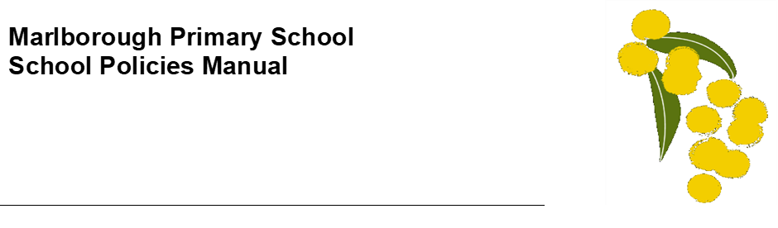

**Help for non-English speakers**

If you need help to understand the information in this policy please contact the Principal.

**Purpose**

The purpose of the Student Dress Code is to outline Marlborough Primary School’s requirements for student dress and appearance and to provide information about uniform purchase and support, dress code implementation and exemption processes.

This dress code has been developed by Marlborough Primary School’s School Council in close consultation with our school community to ensure that it respects the rights of individual students whilst reflecting the values and interests of our community.

The Student Dress Code aims to:

* foster a sense of community and belonging and encourages students to develop pride in their appearance
* support Marlborough Primary School’s commitment to ensuring that our students feel equal and are dressed safely and appropriately for school activities.
* reduce student competition on the basis of clothing
* enhance the profile and identity of the school and its students within the wider community.

The School Council has developed a dress code that we believe provides a range of choices for students and is cost effective for families.

**Scope**

Students are expected to comply with this Student Dress Code while traveling to and from school, during school hours and when attending school activities.

**Uniform and appearance**

The full list of Marlborough Primary School’s compulsory school uniform items are available at Appendix A to this policy.

**General appearance**

While at school, travelling to or from school or participating in school activities, Marlborough Primary School students must comply with the following:

* Uniforms must be clean and in good repair
* Uniforms must be clearly marked with the owner’s name
* Additional layers of clothing may be worn underneath the uniform for added warmth, provided these undergarments are completely hidden.
* Sports Shoes/ Runners / Sneakers are able to be worn as part of the daily uniform.

**Jewellery and cosmetics**

Students are not permitted to wear decorative jewellery to school. Stud earrings and sleepers worn in the ears, and watches, are the only acceptable jewellery.

Cosmetics may not be worn at school. Only clear nail polish is permitted.

**Hair and Sun safety**

Shoulder length or longer hair is to be tied back to help restrict the spread of nits and lice and for student safety.

Extreme hair colours (eg: green, pink or purple rinses or dyes) and/or extreme hairstyles (eg: spikes or mohawks) are not permitted.

School uniform hats must be worn outside from mid-August (exact date to be set by the school annually) to 30 April and on any other day prescribed by the school. School uniform hats may also be worn outside of this time period, by parent or student choice.

Hats are not to be worn inside.

Students are permitted to wear sunglasses during outdoor activities. Sunglasses should be close-fitting, wrap-around that meet the Australian Standards 1067 and cover as much of the eye area as possible.

**Purchase of uniforms**

Uniform items can be purchased from the office at school, or parents may order it directly from PSW on their website.

Marlborough Primary School Parents’ Association also operates a second-hand uniform store for parents.

**Support for families experiencing difficulty**

Please contact the Principal to discuss support that we may be able to provide to families experiencing difficulty meeting uniform costs, including information about eligibility for uniform support through State Schools’ Relief. Further information about State Schools’ Relief is also available on their website: [htps://www.ssr.net.au/](https://www.ssr.net.au/)

Marlborough Primary School also has uniforms available to families to borrow on request.

**Implementation**

Marlborough Primary School will ensure that this Student Dress Code is communicated to all families and students through our website and Compass. We will assist students who may be experiencing difficulties complying with this policy where possible.

Students wearing non-compliant uniform items may be asked to change into a compliant item of clothing provided by the school.

If a student is out of school uniform or otherwise breaches the Student Dress Code on a recurring basis, a note will be provided to the student and parents by the classroom teacher. If non-compliance with the dress code becomes a continued occurrence, the Principal will be informed and a phone call home may be required. In this event, the school will continue to work with the student and family to support compliance.

Measures taken by Marlborough Primary School to address concerns about student non-compliance with the Student Dress Code will also be addressed in accordance with our Student Wellbeing and Engagement Policy.

**EXEMPTIONS TO student dress code**

We recognise that there may be situations where the application of this dress code may affect students unequally.

Students and their parents or carers may apply either in writing or in person to the Principal for an exemption to this Student Dress Code if:

* an aspect of this code prevents the student from complying with a requirement of their religious, ethnic or cultural beliefs or background
* the student has a particular disability or health condition that requires a departure from the dress code
* the student or their parents/carers can demonstrate particular economic hardship that prevents them from complying with the dress code.

When the Principal receives a request for an exemption, they will:

* consider the grounds for the exemption request
* explain the process to the student and/or their parents/carers
* encourage the student and/or their parents/carers to support their application with evidence.

The Principal or delegate will then try to negotiate a resolution that is acceptable to all parties. If an exemption is not allowed, then written reasons will be provided to the student and/or their parents or carers.

**Concerns about this student dress code**

Marlborough Primary School welcomes feedback from the school community in relation to this Student Dress Code. If you have a concern or complaint about the Student Dress Code, further information about raising a concern or complaint is available in our school’s *Parent Complaint Policy*.

**COMMUNICATION**

This policy will be communicated to our school community in the following ways:

* Available publicly on our school’s website (or insert other online parent/carer/student communication method)
* Reminders in our school newsletter
* Discussed at staff briefings/meetings as required
* Discussed at parent information nights/sessions
* Hard copy available from school administration upon request

**Further information and resources**

* Marlborough Primary School SunSmart Policy
* Marlborough Primary School Parent Complaint Policy
* Marlborough Primary School Student Wellbeing and Engagement Policy
* Department of Education and Training [Student Dress Code](https://www2.education.vic.gov.au/pal/student-dress-code/policy)
* Department of Education and Training [Student Engagement policies and guidelines](https://www2.education.vic.gov.au/pal/student-engagement/policy).

**POLICY REVIEW AND APPROVAL**

|  |  |
| --- | --- |
| Policy last reviewed | August 2022 |
| Consultation | Education Committee and School Council |
| Approved by | School Council |
| Next scheduled review date | August 2024 |

**APPENDIX A: MARLBOROUGH PRIMARY SCHOOL UNIFORM ITEMS**

