Mathematics Glossary

Algorithm
A well-defined set of instructions designed to perform a particular task or solve a type of problem, such as determining which of two fractions is larger, bisecting an angle, or calculating the mean of a set of numbers.

Angle
An angle is the figure formed by two rays sharing a common endpoint, called the vertex of the angle.

The size of an angle
Imagine that the ray OB is rotated about the point O until it lies along OA. The amount of turning is called the size of the angle AOB.
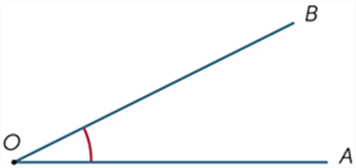

A revolution is the amount of turning required to rotate a ray about its endpoint until it falls back onto itself. The size of 1 revolution is 360°.
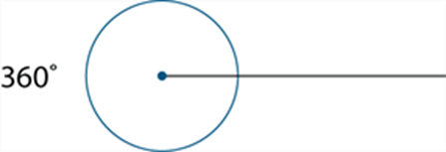
A straight angle is the angle formed by taking a ray and its opposite ray. A straight angle is half of a revolution, and so has size equal to 180°.
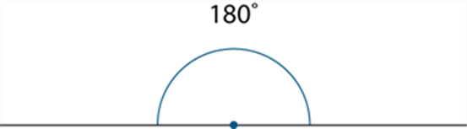

Right angle
Let AOB be a line, and let OX be a ray making equal angles with the ray OA and the ray OB. Then the equal angles ∠AOX and ∠BOX are called right angles.
A right angle is half of a straight angle, and so is equal to 90°.

Classification of angles
Angles are classified according to their size.
We say that
- An angle with size α is acute if 0° < α < 90°,
- An angle with size α is obtuse if 90° < α < 180°,
- An angle with size α is reflex if 180° < α < 360°

Array
An array is an ordered collection of objects or numbers. Rectangular arrays are commonly used in primary mathematics.

Back-to-back stem-and-leaf plot
A back-to-back stem-and-leaf plot is a method for comparing two data distributions by attaching two sets of ‘leaves’ to the same ‘stem’ in a stem-and-leaf plot.
For example, the stem-and-leaf plot below displays the distribution of pulse rates of 19 students before and after gentle exercise.
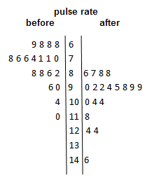

Capacity
Capacity is a term used to describe how much a container will hold. It is often used in relation to the volume of fluids. Units of capacity (volume of fluids or gases) include litres and millilitres.

Cartesian coordinate system
Two intersecting number lines are taken intersecting at right angles at their origins to form the axes of the coordinate system.
The plane is divided into four quadrants by these perpendicular axes called the x-axis (horizontal line) and the y-axis (vertical line).
The position of any point in the plane can be represented by an ordered pair of numbers (x, y). These ordered are called the coordinates of the point. This is called the Cartesian coordinate system. The plane is called the Cartesian plane.
The point with coordinates (4, 2) has been plotted on the Cartesian plane shown. The coordinates of the origin are (0, 0).
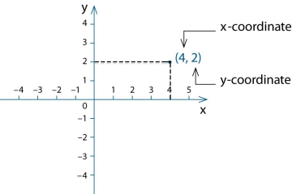

Circle
The circle with centre O and radius r is the set of all points in the plane whose distance from O is r.
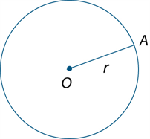
The line segment OA (interval OA) is also called a radius of the circle.
Putting the point of a pair of compasses at the centre and opening the arms to the radius can draw a circle.
Pi is the name of the Greek letter $π$, that is used to denote the ratio of the circumference of any circle to its diameter. The number $π$ is irrational, but$22/7$ is a rational approximation accurate to 2 decimal places. The decimal expansion of $π$ begins $π=3.14159265358979⋯.$
There is a very long history of attempts to estimate $π$ accurately. One of the early successes was due to Archimedes (287–212 BC) who showed that $3\frac{10}{71}< π <3\frac{1}{7}$.
The decimal expansion of $π$ has now been calculated to at least the first ${10}^{12}$ places.

Co-interior angles
In each diagram the two marked angles are called co-interior angles and lie on the same side of the transversal.
If the lines AB and CD are parallel then a + b = 180°
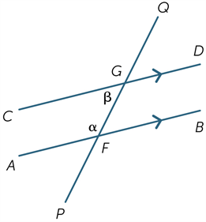
Co-interior angles formed by parallel lines are supplementary.
Conversely, if a pair of co-interior angles is supplementary then the lines are parallel.

Column graph
A column graph is a graph used in statistics for organising and displaying categorical data.
To construct a column graph, equal width rectangular bars are constructed for each category with height equal to the observed frequency of the category as shown in the example below which displays the hair colours of 27 students.
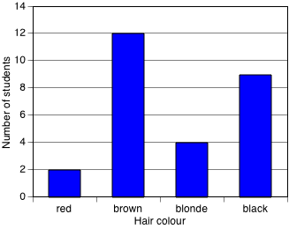
Column graphs are frequently called bar graphs or bar charts. In a bar graph or chart, the bars can be either vertical or horizontal.
A histogram is a statistical graph for displaying the frequency distribution of continuous data.
A histogram is a graphical representation of the information contained in a frequency table. In a histogram, class frequencies are represented by the areas of rectangles centred on each class interval. The class frequency is proportional to the rectangle’s height when the class intervals are all of equal width.
The histogram below displays the frequency distribution of the heights (in cm) of a sample of 42 people with class intervals of width 5 cm.
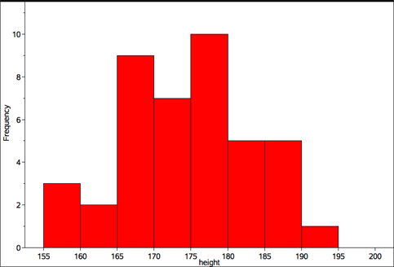

Common factor
A common factor (or common divisor) of a set of numbers or algebraic expression is a factor of each element of that set.
For example,$6$ is a common factor of $24, 54$ and $66$, and$x+1$ is a common factor of$x^{2}-1$ and$x^{2}+5x+4$.

Composite number
A natural number that has a factor other than 1 and itself is a composite number.
Two figures are congruent when we can match every part of one figure with the corresponding part of the other figure. For example, the two figures below are congruent.
Matching intervals have the same length, and matching angles have the same size.

Counting number
The counting numbers are the non-negative integers, that is, one of the numbers $0,1,2,3,⋯$.
Sometimes it is taken to mean only a positive integer.
A natural number is a positive integer or counting number. The natural numbers are $1,2,3,⋯$. The set of natural numbers is usually denoted by $N$.

Counting on
Counting a collection, or reciting a sequence of number words, from a point beyond the beginning of the sequence.
For example, when a child has counted to establish that there are 6 objects in a collection and is then asked “How Many?” after several more are added, might count on from 6 saying “7, 8, 9,...” to reach the total. This is considered a more sophisticated strategy than counting the whole collection from 1.

Data
Data is a general term for a set of observations and measurements collected during any type of systematic investigation.
Primary data is data collected by the user. Secondary data is data collected by others. Sources of secondary data include, web-based data sets, the media, books, scientific papers, etc.
Univariate data is data relating to a single variable, for example, hair colour or the number of errors in a test.

Data display
A data display is a visual format for organising and summarising data.
Examples include, box plots, column graphs, frequency tables and stem plots.

Decimal
A decimal is a numeral in the decimal number system.
For example, the decimal expansion of $6\frac{3}{4}$ is $6.75$. The integer part is $6$ and the fractional part is $0.75$.
A decimal is terminating if the fractional part has only finitely many decimal digits. It is non-terminating if it has infinitely many digits.
For example, $6.75$ is a terminating decimal, whereas $0.3161616⋯$, where the pattern 16 repeats indefinitely, is non-terminating.
Non-terminating decimals may be recurring, that is, contain a pattern of digits that repeats indefinitely after a certain number of places.
For example, $0.3161616⋯$, is a recurring decimal, whereas $0.101001000100001⋯$, where the number of 0’s between the 1’s increases indefinitely, is not recurring.
It is common practice to indicate the repeating part of a recurring decimal by using dots or lines as superscripts.
For example, $0.3161616⋯$, could be written as $0.3\dot{1}\dot{6}$ or $0.3\overline{16}$.
The decimal number system is the base 10, place-value system most commonly used for representing real numbers. In this system positive numbers are expressed as sequences of Arabic numerals 0 to 9, in which each successive digit to the left or right of the decimal point indicates a multiple of successive powers (respectively positive or negative) of 10.
For example, the number represented by the decimal $12.345$ is the sum $1 ×{10}^{1}+2×{10}^{0}+3×{10}^{-1}+4×{10}^{-2}+5×{10}^{-3}$.

Decision
A process by which a selection or choice is made from a set of alternatives, such as halving a selected number if it is even or doubling a selected number if it is odd.

Denominator
In the fraction $\frac{a}{b}$, $b$ is the denominator. It is the number of equal parts into which the whole is divided in order to obtain fractional parts. For example, if a line segment is divided into $5$ equal parts, each of those parts is one fifth of the whole and corresponds to the unit fraction $\frac{1}{5}$.

Dependent variable
Two events are independent if knowing the outcome of one event tells us nothing about the outcome of the other event.

Difference
A difference is the result of the subtraction of one number or algebraic quantity from another.

Distributive
Multiplication of numbers is distributive over addition because the product of one number with the sum of two others equals the sum of the products of the first number with each of the others. This means that we can multiply two numbers by expressing one (or both) as a sum and then multiplying each part of the sum by the other number (or each part of its sum.)
For example,
This distributive law is expressed algebraically as follows:

Divisible
In general, a number or algebraic expression $x$ is divisible by another $y$ if there exists a number or algebraic expression $q$ of a specified type for which $x=yq$.
A natural number $m$ is divisible by a natural number $n$ if there is a natural number $q$ such that $m=nq$.
For example, $12$ is divisible by 4 because $12=3×4$.

Dot plot
A dot plot is a graph used in statistics for organising and displaying numerical data.
Using a number line, a dot plot displays a dot for each observation. Where there is more that one observation, or observations are close in value, the dots are stacked vertically. If there are a large number of observations, dots can represent more than one observation. Dot plots are ideally suited for organising and displaying discrete numerical data.
The dot plot below displays the number of passengers observed in 32 cars stopped at a traffic light.
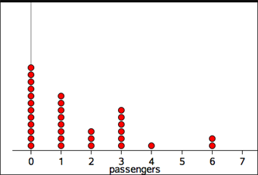
Dot plots can also be used to display categorical data, with the numbers on the number line replaced by category labels.

Element
An element of a set is a member of that set. For example, the elements of the set $\{2,3,4,6,8\}$ are the numbers $2,3,4,6$ and $8$. We write $x∈S$ to indicate that $x$ is a member of the set $S$.

Enlargement (Dilation)
An enlargement is a scaled up (or down) version of a figure in which the transformed figure is in proportion to the original figure. The relative positions of points are unchanged and the two figures are similar.
In the diagram below triangle A′B′C′ is the image of triangle ABC under the enlargement with enlargement factor 2 and centre of enlargement O.
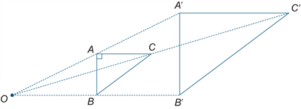

Equally Likely outcomes
Equally likely outcomes occur with the same probability.
For example, in tossing a fair coin, the outcome ‘head’ and the outcome ‘tail’ are equally likely.
In this situation, Pr(head) = Pr(tail) = 0.5

Equation
An equation is a statement that asserts that two numbers or algebraic expressions are equal in value. An equation must include an equal sign. For example, $3+14=11+6$.
An identity is an equation involving algebraic expressions that is true for all values of the variables involved.
For example $x^{2}-4=(x-2)(x+2)$.
An identity is an equation that is true for all values of the variables involved.
Example: $x^{2}-y^{2}=(x-y)(x+y)$.
An inequality is a statement that one number or algebraic expression is less than (or greater than) another. There are four types of inequalities:
- The relation $a$ is less than $b$ is written $a<b$,
- $a$ is greater than $b$ is written $a>b$,
- $a$ is less than or equal to $b$ is written $a≤b$, and
- $a$ is greater than or equal to $b$ is written $a≥b$.

Equivalent fractions
Two fractions $\frac{a}{b}$ and $\frac{c}{d}$ are equivalent if they are equal, that is, $ad=bc$.
Equivalent fractions are alternative ways of writing the same fraction.
For example, $\frac{1}{2}=\frac{2}{4}=\frac{3}{6}=⋯$.

Estimate
In statistical terms, an estimate is information about a population extrapolated from a sample of the population.
For example, the mean number of decayed teeth in a randomly selected group of eight-year old children is an estimate of the mean number of decayed teeth in eight-year old children in Australia.

Even number
A whole number is even if it is divisible by 2. The even whole numbers are $0,2,4,6,⋯$.

Event
An event is a subset of the sample space for a random experiment.
For example, the set of outcomes from tossing two coins is { HH,HT,TH,TT }, where H represents a ‘head’ and T a ‘tail’.
For example, if A is the event ‘at least one head is obtained’, then A = { HT,TH, HH }.
Two events A and B are mutually exclusive if one is incompatible with the other; that is, if they cannot be simultaneous outcomes in the same chance experiment.
For example, when a fair coin is tossed twice, the events ‘HH’ and ‘TT’ cannot occur at the same time and are, therefore, mutually exclusive.
In a Venn diagram, as shown below, mutually exclusive events do not overlap.
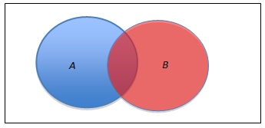

Expression
Two or more numbers or variables connected by operations. For example, 17 – 9, 8 x (2 + 3), 2a + 3b are all expressions. Expressions do not include an equal sign.

Factor
In general, a number or algebraic expression $x$ is a factor (or divisor) of another $y$ if there exists a number or algebraic expression $q$ of a specified type for which $y=xq.$
A natural number $m$ is a factor of a natural number $n$ if there is a natural number $q$ such that $n=mq.$
For example, $4$ is a factor of 12 because $12=3×4$
A polynomial $a(x)$ is divisible by a polynomial $b(x)$ if there is a polynomial $q(x)$ for which $a\left(x\right)=b\left(x\right)q(x)$.
For example, $x-2$ is a factor of $x^{2}-6x+8$ because $x^{2}-6x+8=(x-4)(x-2)$.
A prime factor of a natural number $n$ is a factor of $n$ that is a prime number.
For example, the prime factors of $330$ are $2,3,5$ and $11$.

Factor and remainder theorem
According to the factor theorem, if $p(x)$ is a polynomial and $p\left(a\right)=0$ for some number $a$, then $p\left(x\right)$ is divisible by $x-a$.
This follows easily from the remainder theorem, because for $p(x)÷(x-a)$ the remainder is $p(a)$ So if $p\left(a\right)=0$, the remainder is 0 and $p(x)$ is divisible by $x-a$.
The factor theorem can be used to obtain factors of a polynomial.
For example, if $p\left(x\right)=x^{3}-3x^{2}+5x-6$, then it is easy to check that $p\left(2\right)=2^{3}-3×2^{2}+5×2-6=0$. So by the factor theorem $x-2$ is a factor of $x^{3}-3x^{2}+5x-6$.
According to the remainder theorem, if a polynomial $p(x)$ is divided by $x-a$ where $a$ is any real number, the remainder is $p\left(a\right).$ That is, $p\left(x\right)=q\left(x\right)\left(x-a\right)+p(a)$, for some polynomial $q(x)$.

Factorise
To factorise a number or algebraic expression is to express it as a product.
For example, $15$ is factorised when expressed as a product: $15=3×5$, and $x^{2}-3x+2$ is factorised when written as a product:

Fraction
The fraction $\frac{a}{b}$ (written alternatively as $a/b$), where $a$ is a non-negative integer and $b$ is a positive integer, was historically obtained by dividing a unit length into $b$ equal parts and taking $a$ of these parts.
For example, $\frac{3}{5}$ refers to 3 of 5 equal parts of the whole, taken together.
In the fraction $\frac{a}{b}$ the number $a$ is the numerator and the number $b$ is the denominator.
It is a proper fraction if $a<b$ and an improper fraction otherwise.

Frequencies
Frequency, or observed frequency, is the number of times that a particular value occurs in a data set.
For grouped data, it is the number of observations that lie in that group or class interval.
An expected frequency is the number of times that a particular event is expected to occur when a chance experiment is repeated a number of times. For example, If the experiment is repeated n times, and on each of those times the probability that the event occurs is p, then the expected frequency of the event is np.
For example, suppose that a fair coin is tossed 5 times and the number of heads showing recorded. Then the expected frequency of ‘heads’ is 5/2.
This example shows that the expected frequency is not necessarily an observed frequency, which in this case is one of the numbers 0,1,2,3,4 or 5.
A frequency table lists the frequency (number of occurrences) of observations in different ranges, called class intervals.
The frequency distribution of the heights (in cm) of a sample of 42 people is displayed in the frequency table below

Height (cm)
Class interval | Frequency
155-<160 | 3
160-<165 | 2
165-<170 | 9
170-<175 | 7
175-<180 | 10
180-<185 | 5
185-<190 | 5
185-<190 | 5
A frequency distribution is the division of a set of observations into a number of classes, together with a listing of the number of observations (the frequency) in that class.
Frequency distributions can be displayed in tabular or graphical form.
Frequency, or observed frequency, is the number of times that a particular value occurs in a data set.
For grouped data, it is the number of observations that lie in that group or class interval.
Relative frequency is given by the ratio , where f is the frequency of occurrence of a particular data value or group of data values in a data set and n is the number of data values in the data set.

Frequency table
A two-way frequency table is commonly used for displaying the two-way frequency distribution that arises when a group of individuals or things are categorised according to two criteria.
For example, the two-way table below displays the two-way frequency distribution that arises when 27 children are categorised according to hair type (straight or curly) and hair colour (red, brown, blonde, black).
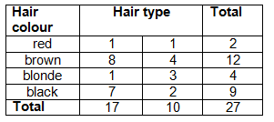
The information in a two-way frequency table can also be displayed graphically using a side-by-side column graph.

Function
A function $f$ assigns to each element of one set $S$ precisely one element of a second set $T$.
The functions most commonly encountered in elementary mathematics are real functions of real variables. For such functions, the domain and codomain are sets of real numbers.
Functions are usually defined by a formula for $f(x)$ in terms of $x$. For example, the formula $f\left(x\right)=x^{2}$, defines the ‘squaring function’ that maps each real number $x$ to its square $x^{2}$.

Gradient
If A(x₁,y₁) and points B(x₂, y₂) are points in the plane, x₂ – x₁ ≠ 0, the gradient of the line segment (interval)
AB = $\frac{rise}{run}$ = $\frac{y_{2}-y_{1}}{x_{2}- x_{2}}$.
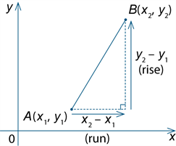
The gradient of a line is the gradient of any line segment (interval) within the line.

Greatest common divisor
The greatest common divisor (gcd), greatest common factor (gcf) or highest common factor (hcf), of a given set of natural numbers is the common divisor of the set that is greater than each of the other common divisors.
For example, $1,2,3$ and $6$ are the common factors of 24,54 and 66 and 6 is the greatest common divisor.

Histogram
A histogram is a statistical graph for displaying the frequency distribution of continuous data.
A histogram is a graphical representation of the information contained in a frequency table. In a histogram, class frequencies are represented by the areas of rectangles centred on each class interval. The class frequency is proportional to the rectangle’s height when the class intervals are all of equal width.
The histogram below displays the frequency distribution of the heights (in cm) of a sample of 42 people with class intervals of width 5 cm.

Independent event
Two events are independent if knowing the outcome of one event tells us nothing about the outcome of the other event.

Independent variable
When investigating relationships in bivariate data, the explanatory variable is the variable that may explain or cause a difference in the response variable.
For example, when investigating the relationship between the temperature of a loaf of bread and the time it has spent in a hot oven, temperature is the response variable and time is the explanatory variable.
With numerical bivariate data it is common to attempt to model such relationships with a mathematic equation and to call the response variable the dependent variable and the explanatory variable the independent variable.
When graphing numerical data, the convention is to display the response (dependent) variable on the vertical axis and the explanatory (independent) variable on the horizontal axis.
When there is no clear causal link between the events, the classification of the variables as either the dependent or independent variable is quite arbitrary.

Index
Index is synonymous with exponent.
The exponent or index of a number or algebraic expression is the power to which the latter is be raised. The exponent is written as a superscript. Positive integral exponents indicate the number of times a term is to be multiplied by itself. For example, $a^{3}=a×a×a$.

Index law
Index laws are rules for manipulating indices (exponents). They include
and

Informal unit
Informal units are not part of a standardised system of units for measurement. For example, an informal unit for length could be paperclips of uniform length. An informal unit for area could be uniform paper squares of any size. Informal units are sometimes referred to as non-standard units.

Integer
The integers are the ‘whole numbers’ $⋯,-3,-2,01,0,1,2,3,⋯$. The set of integers is usually denoted by $Z.$ Integers are basic building blocks in mathematics.

Interquartile range
The interquartile range (IQR) is a measure of the spread within a numerical data set. It is equal to the upper quartile (Q₃) minus the lower quartiles (Q₁); that is, IQR = Q₃ – Q_{1.}
The IQR is the width of an interval that contains the middle 50% (approximately) of the data values. To be exactly 50%, the sample size must be a multiple of four.

Interval
An interval is a certain type of subset of the number line.
A finite interval is the set of all real numbers between two given real numbers called the end points of the interval. The end points may or may not be included in the interval.

Irrational number
An irrational number is a real number that is not rational. Some commonly used irrational numbers are π, e and $\sqrt{2}$.
The Euler number is an irrational real number whose decimal expansion begins$e=2.718281828⋯$.

Irregular shape
An irregular shape can be a polygon. A polygon that is not regular is irregular.

Iteration
The repetition of a process a specified number of times, or until a condition is satisfied, such as subtracting 4 from 27 six times or subtracting 4 from 27 until the result is less than 4.

Kite
A kite is a quadrilateral with two pairs of adjacent sides equal.
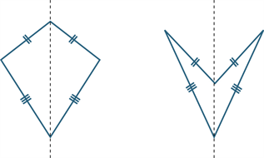
A kite may be convex as shown in the diagram above to the left or non-convex as shown above to the right. The axis of the kite is shown.

Line segment (Interval)
If A and B are two points on a line, the part of the line between and including A and B is called a line segment or interval.
The distance AB is a measure of the size or length of AB.
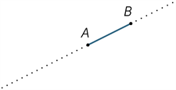
Any point A on a line divides the line into two pieces called rays. The ray AP is that ray which contains the point P (and the point A). The point A is called the vertex of the ray and it lies on the ray.
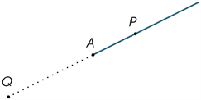

Linear equation
A linear equation is an equation involving just linear terms, that is, polynomials of degree 1. The general form of a linear equation in one variable is $ax+b=0$.

Location (statistics)
A measure of location is a single number that can be used to indicate a central or ‘typical value’ within a set of data.
The most commonly used measures of location are the mean and the median although the mode is also sometimes used for this purpose.

Logarithm
The logarithm of a positive number $x$ is the power to which a given number $b$, called the base, must be raised in order to produce the number $x$. The logarithm of $x$, to the base $b$ is denoted by $\log_{b}{x}$. Algebraically: $\log_{b}{x}=y↔b^{y}=x$.
For example, $\log_{10}{100}=2$ because ${10}^{2}=100$, and $\log_{2}({\frac{1}{32})=-5}$ because $2^{-5}=\frac{1}{32}$.

Many-to-one correspondence
A many-to-one correspondence is a function or mapping that takes the same value for at least two different elements of its domain. For example, the squaring function $x⟼ x^{2}$ is many-to-one because $x^{2}= {(-x)}^{2}$ for all real numbers $x$.

Mean
The arithmetic mean of a list of numbers is the sum of the data values divided by the number of numbers in the list.
In everyday language, the arithmetic mean is commonly called the average.
For example, for the following list of five numbers { 2, 3, 3, 6, 8 } the mean equals $\frac{2+3+3+6+8}{5}=\frac{22}{5}=4.4$.

Median
The median is the value in a set of ordered data that divides the data into two parts. It is frequently called the ‘middle value’.
Where the number of observations is odd, the median is the middle value.
For example, for the following ordered data set with an odd number of observations, the median value is five.
1 3 3 4 5 6 8 9 9
Where the number of observations is even, the median is calculated as the mean of the two central values.
For example, in the following ordered data set, the two central values are 5 and 6, and median value is the mean of these two values, 5.5.
1 3 3 4 5 6 8 9 9 10
The median provides a measure of location of a data set that is suitable for both symmetric and skewed distributions and is also relatively insensitive to outliers.

Midpoint
The midpoint M of a line segment (interval) AB is the point that divides the segment into two equal parts.
Let A(x₁, y₁) be points in the Cartesian plane. Then the midpoint M of line segment AB has coordinates $(\frac{x_{1}+x_{2}}{2},\frac{x_{1}+x_{2}}{s})$.
This can be seen from the congruent triangles below.
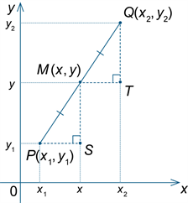

Mode
The mode is the most frequently occurring value in a set of data. There can be more than one mode. When there are two modes, the data set is said to be bimodal.
The mode is sometimes used as a measure of location.

Monic
A monic polynomial is one in which the coefficient of the leading term is 1. For example, $x^{3}+{2x}^{2}-7$ is monic, but ${4x}^{2}-x+1$ is not.

Multiple
A multiple of a number is the product of that number and an integer.
A multiple of a real number $x$ is any number that is a product of $x$ and an integer. For example, $4.5$ and -10.5 are multiples of $1.5$ because $4.5=3×1.5$ and $-10.5=-7×1.5$.

Multiplication
Multiplicative situations are problems or contexts that involve multiplication (or division). Calculating the number of seats in a theatre that has 30 rows of 24 seats, finding equivalent fractions, and working with ratios and percentages are all multiplicative situations.

Net
A net is a plane figure that can be folded to form a polyhedron.
One possible net for a cube is shown below.
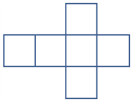

Number
A real number is rational if it can be expressed as a quotient of integers. It is irrational otherwise.

Number line
A number line gives a pictorial representation of real numbers.

Numeral
A figure or symbol used to represent a number. For example, -3, 0, 45, IX

Numerator
In the fraction $\frac{a}{b}$, $a$ is the numerator. If an object is divided into $b$ equal parts, then the fraction $\frac{a}{b}$ represents $a$ of these parts taken together. For example, if a line segment is divided into $5$ equal parts, each of those parts is one fifth of the whole and 3 of these parts taken together corresponds to the fraction​ $\frac{3}{5}$.

Numerical data
Numerical data is data associated with a numerical variable.
Numerical variables are variables whose values are numbers, and for which arithmetic processes such as adding and subtracting, or calculating an average, make sense.

Odd and even number
A whole number is even if it is divisible by 2. The even whole numbers are $0,2,4,6,⋯$.
An odd number is an integer that is not divisible by 2. The odd numbers are $⋯-5,-3,-1,1,3,5,⋯$.

One-to-one correspondence
In early counting development one-to-one correspondence refers to the matching of one and only one number word to each element of a collection.
More generally it refers to a relationship between two sets such that every element of the first set corresponds to one and only one element of the second set.​

Operation
The process of combining numbers or expressions. In the primary years operations include addition, subtraction, multiplication and division. In later years operations include substitution and differentiation.

Order of operations
A convention for simplifying expressions that stipulates that multiplication and division are performed before addition and subtraction and in order from left to right. For example, in 5 – 6 ÷ 2 +7, the division is performed first and the expression becomes 5 – 3 + 7 = 9. If the convention is ignored and the operations are performed in order, the incorrect result, 6.5 is obtained.

Outlier
An outlier is a data value that appears to stand out from the other members of the data set by being unusually high or low. The most effective way of identifying outliers in a data set is to graph the data.
For example, in following list of ages of a group of 10 people, { 12, 12, 13, 13, 13, 13, 13, 14, 14, 14, 24 }, the 24 would be considered to be a possible outlier.
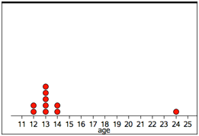

Parabola
Definition 1
The graph of y = x² is called a parabola. The point (0, 0) is called the vertex of the parabola and the y axis is the axis of symmetry of the parabola called simply the axis.
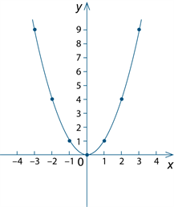
Some other parabolas are the graphs of y = ax² + bx + c where a ≠ 0.
More generally, every parabola is similar to the graph of y = x².
Definition 2
A parabola is the locus of all points P such that the distance from P to a fixed point F is equal to the distance from P to a fixed line l.

Parallel box plots
Parallel box-and-whisker-plots are used to visually compare the five-number summaries of two or more data sets.
For example, box-and-whisker-plots below can be used to compare the five-number summaries for the pulse rates of 19 students before and after gentle exercise.
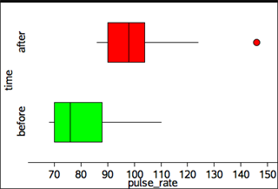
Note that the box plot for pulse rates after exercise shows the pulse rate of 146 as a possible outlier (.). This is because the distance of this data point above the upper quartile 42 (146-104) is more than 21 (1.5 ´ IQRs = 1.5 ´ (104 – 90) = 1.5 ´ 14 = 21).
The term ‘parallel box-and-whisker plots’ is commonly abbreviated to ‘parallel boxplots’.

Parallelogram
A parallelogram is a quadrilateral whose opposite sides are parallel.
Thus the quadrilateral ABCD shown below is a parallelogram because AB || DC and DA || CB.
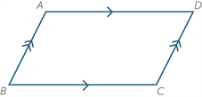
Properties of a parallelogram
- The opposite angles of a parallelogram are equal.
- The opposite sides of a parallelogram are equal.
- The diagonals of a parallelogram bisect each other.

Partitioning
Dividing a quantity into parts. In the early years it commonly refers to the ability to think about numbers as made up of two parts, for example, 10 is 8 and 2. In later years it refers to dividing both continuous and discrete quantities into equal parts.

Percentage
A percentage is a fraction whose denominator is 100.
For example, $6$ percent (written as $6\%$) is the percentage whose value is $\frac{6}{100}$.
Similarly, 40 as a percentage of 250 is $\frac{40}{250}×100=16\%$.

Perimeter
The perimeter of a plane figure is the length of its boundary.

Picture graphs
A picture graph is a statistical graph for organising and displaying categorical data.
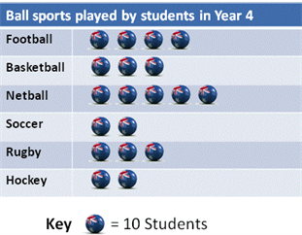

Place value
The value of digit as determined by its position in a number relative to the ones (or units) place. For integers the ones place is occupied by the rightmost digit in the number.
For example in the number 2 594.6 the 4 denotes 4 ones, the 9 denotes 90 ones or 9 tens, the 5 denotes 500 ones or 5 hundreds, the 2 denotes 2000 ones or 2 thousands, and the 6 denotes $\frac{6}{10}$ of a one or 6 tenths.

Point
A point marks a position, but has no size.

Polynomial
A polynomial in one variable $x$ (simply called a polynomial) is a finite sum of terms of the form ${ax}^{k}$, where $a$ is a number and $k$ is a non-negative integer.
A non-zero polynomial can be written in the form $a_{0}+a_{1}x+a_{2}x^{2}+⋯+a_{n}x^{n}$, where $n$ is a non-negative integer and $a_{n}≠0$.

Population
A population is the complete set of individuals, objects, places, etc., that we want information about.
A census is an attempt to collect information about the whole population.

Prime number
A prime number is a natural number greater than 1 that has no factor other than 1 and itself.

Prism
A prism is a convex polyhedron that has two congruent and parallel faces and all its remaining faces are parallelograms.
A right prism is a convex polyhedron that has two congruent and parallel faces and all its remaining faces are rectangles. A prism that is not a right prism is often called an oblique prism.
Some examples of prisms are shown below.
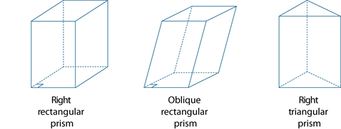

Probability
The probability of an event is a number between 0 and 1 that indicates the chance of something happening.
For example the probability that the sun will come up tomorrow is 1, the probability that a fair coin will come up ‘heads’ when tossed is 0.5, while the probability of someone being physically present in Adelaide and Brisbane at exactly the same time is zero.

Product
A product is the result of multiplying together two or more numbers or algebraic expressions.
For example, $36$ is the product of $9$ and $4$, and $x^{2}-y^{2}$ is product of $x-y$ and $x+y$.

Proportion
Corresponding elements of two sets are in proportion if there is a constant ratio. For example, the circumference and diameter of a circle are in proportion because for any circle the ratio of their lengths is the constant $π$.

Pyramid
A pyramid is a convex polyhedron with a polygonal base and triangular sides that meet at a point called the vertex. The pyramid is named according to the shape of its base.
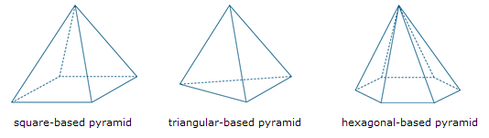

Pythagoras’ theorem
For a right-angled triangle
- The square of the hypotenuse of a right-angled triangle equals the sum of the squares of the lengths of the other two sides.
- In symbols, c² = a² + b².
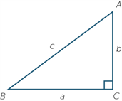
The converse
If c² = a² + b² in a triangle ABC, then ∠C is a right angle.

Quadratic equation
The general quadratic equation in one variable is${ax}^{2}+bx+c=0$, where $a≠0$.
The roots are given by the quadratic formula
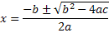

Quadratic expression
A quadratic expression or function contains one or more of the terms in which the variable is raised to the second power, but no variable is raised to a higher power. Examples of quadratic expressions include ${3x}^{2}+7$ and

Quartile
Quartiles are the values that divide an ordered data set into four (approximately) equal parts. It is only possible to divide a data set into exactly four equal parts when the number of data of values is a multiple of four.
There are three quartiles. The first, the lower quartile (Q₁) divides off (approximately) the lower 25% of data values. The second quartile (Q₂) is the median. The third quartile, the upper quartile (Q₃), divides off (approximately) the upper 25% of data values.
Percentiles are the values that divide an ordered data set into 100 (approximately) equal parts. It is only possible to divide a data set into exactly 100 equal parts when the number of data values is a multiple of one hundred.
There are 99 percentiles. Within the above limitations, the first percentile divides off the lower 1% of data values. The second, the lower 2% and so on. In particular, the lower quartile (Q₁) is the 25th percentile, the median is the 50th percentile and the upper quartile is the 75th percentile.

Quotient
A quotient is the result of dividing one number or algebraic expression by another. See also remainder.

Random number
A random number is one whose value is governed by chance; for example, the number of dots showing when a fair die is tossed. The value of a random number cannot be predicted in advance.

Range (statistics)
The range is the difference between the largest and smallest observations in a data set.
The range can be used as a measure of spread in a data set, but it is extremely sensitive to the presence of outliers and should only be used with care.

Rate
A rate is particular kind of ratio in which the two quantities are measured in different units. For example, the ratio of distance to time, known as speed is a rate because distance and time are measured in different units (such as kilometres and hours). The value of the rate depends on the units in which the quantities are expressed.

Ratio
A ratio is a quotient or proportion of two numbers, magnitudes or algebraic expressions. It is often used as a measure of the relative size of two objects. For example the ratio of the length of a side of a square to the length of a diagonal is $1:\sqrt{2}$ that is, $\frac{1}{\sqrt{2}}$.

Rational numbers
See ‘Real numbers’.

Real numbers
The numbers generally used in mathematics, in scientific work and in everyday life are the real numbers. They can be pictured as points on a number line, with the integers evenly spaced along the line, and a real number $b$ to the right of a real number $a$ if $a<b$.
A real number is either rational or irrational.
Every real number has a decimal expansion. Rational numbers are the ones whose decimal expansions are either terminating or recurring.

Rectangle
A rectangle is a quadrilateral in which all angles are right angles.

Rectangular Hyperbola
The graph of y = 1/x is called a rectangular hyperbola. The x and y axes are asymptotes as the curve gets as close as we like to them.
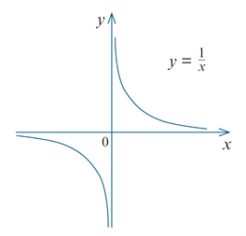

Recurring decimal
A recurring decimal is a decimal that contains a pattern of digits that repeats indefinitely after a certain number of places.
For example,
and this is the decimal expansion of the rational number
Every recurring decimal is the decimal expansion of a rational number

Reflection
To reflect the point A in an axis of reflection, a line has been drawn at right angles to the axis of reflection and the point A′ is marked at the same distance from the axis of reflection as A, but on the other side.
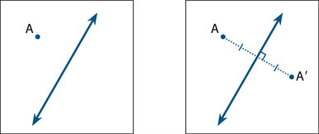
The point A′ is called the reflection image of A.
A reflection is a transformation that moves each point to its reflection image.

Related denominators
Denominators are related when one is a multiple of the other. For example, the fractions $\frac{1}{3}$ and $\frac{5}{9}$ have related denominators because 9 is a multiple of 3.
Fractions with related denominators are more easily added and subtracted than fractions with unrelated denominators because only one needs to be renamed. For example to add $\frac{1}{3}$ and $\frac{5}{9}$ we can rename $\frac{1}{3}$ as $\frac{3}{9}$ and then compute $\frac{3}{9}+ \frac{5}{9}= \frac{8}{9}$.

Remainder
A remainder is the amount left over when one number or algebraic quantity $a$ is divided by another $b$. If $a$ is divisible by $b$ then the remainder is 0.
For example, when 68 is divided by 11, the remainder is 2, because 68 can be expressed as​ $68=6×11+2$.

Rhombus
A rhombus is a quadrilateral with all sides being equal.
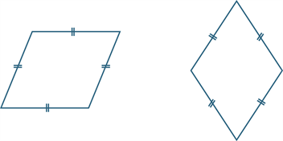

Right Cone
A cone is a solid that is formed by taking a circle called the base and a point not in the plane of the circle, called the vertex, which lies above or below the circle and joining the vertex to each point on the circle.
If the vertex is directly above or below the centre of the circular base, we call the cone a right cone.
The height of the cone is the distance from the vertex to the centre of the circular base.
The slant height of a cone is the distance from any point on the circle to the vertex to the circle.
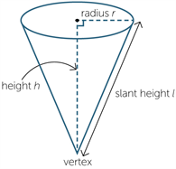

Rotation
A rotation turns a figure about a fixed point, called the centre of rotation.
A rotation is specified by:
- the centre of rotation O
- the angle of rotation
- the direction of rotation (clockwise or anticlockwise).
In the first diagram below, the point A is rotated through 120º clockwise about O. In the second diagram, it is rotated through 60° anticlockwise about O.
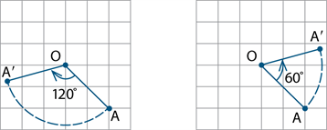
A rotation is a transformation that moves each point to its rotation image.

Rounding
The decimal expansion of a real number is rounded when it is approximated by a terminating decimal that has a given number of decimal digits to the right of the decimal point.
Rounding to $n$ decimal places is achieved by removing all decimal digits beyond (to the right of) the $n^{th}$ digit to the right of the decimal place, and adjusting the remaining digits where necessary.
If the first digit removed (the ${(n+1)}^{th}$ digit) is less than 5 the preceding digit is not changed.
For example, $4.02749$ becomes $4.027$ when rounded to 3 decimal places.
If the first digit removed is greater than 5, or 5 and some succeeding digit is non-zero, the preceding digit is increased by 1. For example, $6.1234586$ becomes $6.12346$ when rounded to 5 decimal places.

Sample
A sample is part of a population. It is a subset of the population, often randomly selected for the purpose of estimating the value of a characteristic of the population as a whole.
For instance, a randomly selected group of eight-year old children (the sample) might be selected to estimate the incidence of tooth decay in eight-year old children in Australia (the population).

Sample space
A sample space is the set of all possible outcomes of a chance experiment. For example, the set of outcomes (also called sample points) from tossing two heads is { HH, HT, TH, TT }, where H represents a ‘head’ and T a ‘tail’.​

Sequence
An ordered set of elements such as numbers, instructions or objects.

Scientific notation
A positive real number is expressed in scientific notation when it is written as the product of a power of $10$ and a decimal that has just one digit to the left of the decimal point.
For example, the scientific notation for $3459$ is $3.459×{10}^{3}$, and the scientific notation for $0.000004567$ is $4.567×{10}^{-6}$.
Many electronic calculators will show these as $3.459E3$ and $4.567E-6$.

Secondary data set
Primary data is data collected by the user. Secondary data is data collected by others. Sources of secondary data include, web-based data sets, the media, books, scientific papers, etc.

Shape (statistics)
The shape of a numerical data distribution is mostly simply described as symmetric if it is roughly evenly spread around some central point or skewed, if it is not. If a distribution is skewed, it can be further described as positively skewed (‘tailing-off’ to the upper end of the distribution) or negatively skewed (‘tailing-off’ to the lower end of the distribution).
These three distribution shapes are illustrated in the parallel dot plot display below.
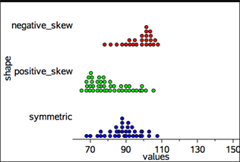
Dot plots, histograms and stem plots can all be used to investigate the shape of a data distribution.

Shapes (geometry)
A polygon is plane figure bounded by line segments.
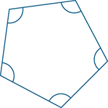
The figure shown above is a regular pentagon. It is a convex five-sided polygon. It is called a pentagon because it has five sides. It is called regular because all sides have equal length and all interior angles are equal.
A polyhedron is a solid figure bounded by plane polygonal faces. Two adjacent faces intersect at an edge and each edge joins two vertices.
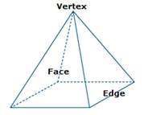
The polyhedron shown above is a pyramid with a square base. It has 5 vertices, 8 edges and 5 faces. It is a convex polyhedron.
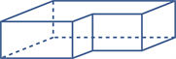
The figure above is a non-convex polyhedron.
A convex polyhedron is a finite region bounded by planes, in the sense that the region lies entirely on one side of the plane.
A regular shape can be a polygon. A polygon is regular if all of its sides are the same length and all of its angles have the same measure.

Side-by-side column graph
A side-by-side column graph can be used to organise and display the data that arises when a group of individuals or things are categorised according to two or more criteria.
For example, the side-by-side column graph below displays the data obtained when 27 children are categorised according to hair type (straight or curly) and hair colour (red, brown, blonde, black). The legend indicates that blue columns represent children with straight hair and red columns children with curly hair.
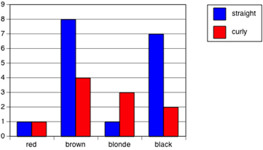
Side-by-side column graphs are frequently called side-by-side bar graphs or bar charts. In a bar graph or chart, the bars can be either vertical or horizontal.

Similar
The four standard tests for two triangles to be similar.
AAA: If two angles of one triangle are respectively equal to two angles of another triangle, then the two triangles are similar.
SAS: If the ratio of the lengths of two sides of one triangle is equal to the ratio of the lengths of two sides of another triangle, and the included angles are equal, then the two triangles are similar.
SSS: If we can match up the sides of one triangle with the sides of another so that the ratios of matching sides are equal, then the two triangles are similar.
RHS: If the ratio of the hypotenuse and one side of a right-angled triangle is equal to the ratio of the hypotenuse and one side of another right-angled triangle, then the two triangles are similar.

Similarity
Two plane figures are called similar if an enlargement of one figure is congruent to the other.
That is, if one can be mapped to the other by a sequence of translations, rotations, reflections and enlargements.
Similar figures thus have the same shape, but not necessarily the same size.

Simple interest
Simple interest is the interest accumulated when the interest payment in each period is a fixed fraction of the principal. For example, if the principle $\$P$ earns simple interest at the rate of $i\%$ per period, then after $n$ periods the accumulated simple interest is $\$Pni/100$.
Sine
In any right-angled triangle,
sin θ = $\frac{opposite}{hypotenuse},$ where 0° < θ < 90°
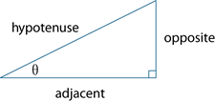
In any triangle ABC,
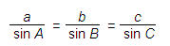
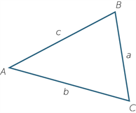
In words it says:
Any side of a triangle over the sine of the opposite angle equals any other side of the triangle over the sine of its opposite angle.
Square
A square is a quadrilateral that is both a rectangle and a rhombus.
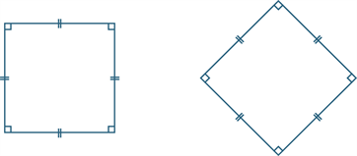
A square thus has all the properties of a rectangle, and all the properties of a rhombus.

Standard deviation
Standard deviation is a measure of the variability or spread of a data set. It gives an indication of the degree to which the individual data values are spread around their mean.

Stem and leaf plot
A stem-and-leaf plot is a method of organising and displaying numerical data in which each data value is split in to two parts, a ‘stem’ and a ‘leaf’.
For example, the stem-and-leaf plot below displays the resting pulse rates of 19 students.
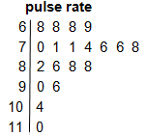
In this plot, the stem unit is ‘10’ and the leaf unit is ‘1’. Thus the top row in the plot 6 | 8 8 8 9 displays pulse rates of 68, 68, 68 and 69.
Stemplot is a synonym for stem-and-leaf plot.

Subitising
Recognising the number of objects in a collection without consciously counting

Sum
A sum is the result of adding together two of more numbers or algebraic expressions.

Surd
A surd is a numerical expression involving one or more irrational roots of numbers. Examples of surds include $\sqrt{2}, \sqrt[3]{5}$ and $4\sqrt{3}+7\sqrt[3]{6}$.

Symmetrical
Line symmetry
A plane figure F has line symmetry in a line m if the image of F under the reflection in m is F itself. The line m is called the axis of symmetry.
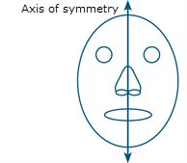
Rotational symmetry
A plane figure F has rotational symmetry about a point O if there is a non-trivial rotation such that the image of F under the rotation is F itself.
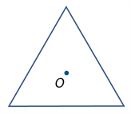
A rotation of 120º around O moves the equilateral triangle onto itself.

Tangent
A tangent to a circle is a line that intersects a circle at just one point. It touches the circle at that point of contact, but does not pass inside it.
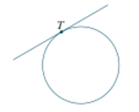

Tangent
In any right-angled triangle,
tan θ = opposite / adjacent, where 0° < θ < 90°.
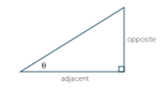

Terminating decimal
A terminating decimal is a decimal that contains only finitely many decimal digits.
Every terminating decimal represents a rational number where the denominator is a power of $10$.
For example, $54.321$ is the decimal expansion of the sum

Transformation
The transformations included in this glossary are enlargements, reflections, rotations and translations.

Translation
Shifting a figure in the plane without turning it is called translation. To describe a translation, it is enough to say how far left or right and how far up or down the figure is moved.
A translation is a transformation that moves each point to its translation image.

Transversal
A transversal is a line that meets two or more other lines in a plane.

Trapezium
A trapezium is a quadrilateral with one pair of opposite sides parallel.
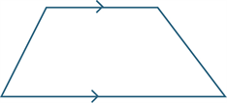

Tree diagram
A tree diagram is a diagram that can used to enumerate the outcomes of a multi-step random experiment.
The diagram below shows a tree diagram that has been used to enumerate all of the possible outcomes when a coin is tossed twice This is an example of a two-step random experiment.
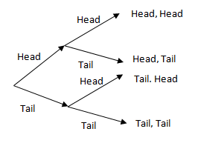

Triangular number
A triangular number is the number of dots required to make a triangular array of dots in which the top row consists of just one dot, and each of the other rows contains one more dot than the row above it. So the first triangular number is $1$, the second is $3 (=1+2)$, the third is $6 (=1+2+3)$ and so on.

Trigonometric ratios
Sine, Cosine, Tangent.

Unit fraction
A unit fraction is a simple fraction whose numerator is 1, that is, a fraction of the form $1/n$, where $n$ is a natural number.

Variable
Numerical variables are variables whose values are numbers, and for which arithmetic processes such as adding and subtracting, or calculating an average, make sense.
A discrete numerical variable is a numerical variable, each of whose possible values is separated from the next by a definite ‘gap’. The most common numerical variables have the counting numbers 0,1,2,3,… as possible values. Others are prices, measured in dollars and cents.
Examples include the number of children in a family or the number of days in a month.

Variable (algebra)
A variable is a symbol, such as $x,y$ or $z$, used to represent an unspecified member of some set. For example, the variable $x$ could represent an unspecified real number.

Variable (statistics)
A variable is something measurable or observable that is expected to either change over time or between individual observations.
Examples of variables in statistics include the age of students, their hair colour or a playing field’s length or its shape.​

Venn diagram
A Venn diagram is a graphical representation of the extent to which two or more events, for example A and B, are mutually inclusive (overlap) or mutually exclusive (do not overlap).
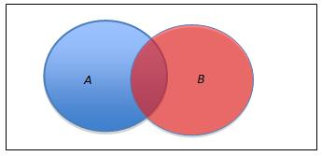

Vertically opposite angle
When two lines intersect, four angles are formed at the point of intersection. In the diagram, the angles marked ∠AOX and ∠BOY are called vertically opposite.
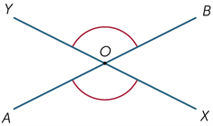Vertically opposite angles are equal.

Volume
The volume of a solid region is a measure of the size of a region.
For a rectangular prism, Volume = Length × Width × Height.

Whole number
A whole number is a non–negative integer, that is, one of the numbers $0,1,2,3,⋯$.
Sometimes it is taken to mean only a positive integer, or any integer.

